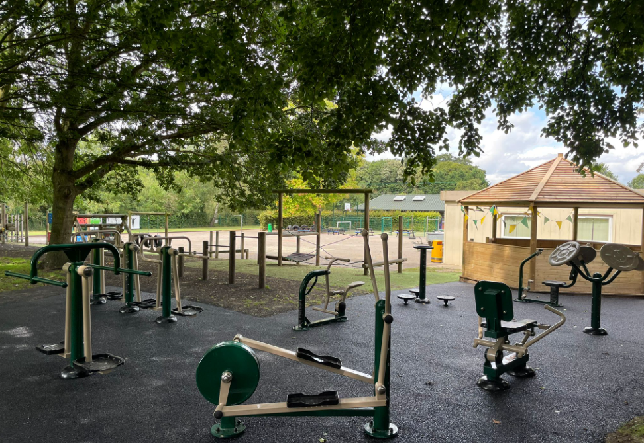
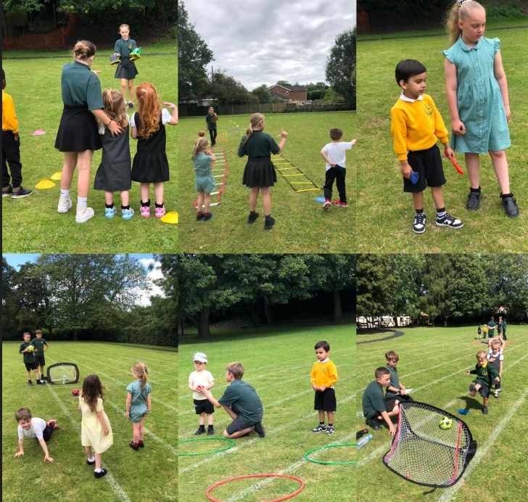
Support for review and reflection - considering the 5 key indicators from DfE, what development needs are a priority for your setting and your students now and why? Use the space below to reflect on previous spend, identify current need and priorities for the future.

Key achievements to date: | Areas for further improvement and baseline evidence of need:
Priority of PE raised throughout the school, through positive role models and high quality sports teaching for all children.  Playground equipment significantly enhanced ensuring a more active playtimes and lunchtimes  Variety of non ‘sports based’ activities greatly enhanced, including ‘games’, and musical theatre  Increased numbers of children attending extra-curricular ‘active’ clubs | Increase staff participation in delivery of active lessons and activities  Further increase levels of activity of children during a ‘regular school day’  Continue to develop physical environment to encourage outside activity based play

Meeting national curriculum requirements for swimming and water safety | Please complete all of the below:
What percentage of your current Year 6 cohort swim competently, confidently and proficiently over a distance of at least 25 metres?  N.B. Even though your children may swim in another year please report on their attainment on leaving  primary school. | 79%
What percentage of your current Year 6 cohort use a range of strokes effectively [for example, front crawl, backstroke and breaststroke]? | 73%
What percentage of your current Year 6 cohort perform safe self-rescue in different water-based situations? | 68%
Schools can choose to use the Primary PE and Sport Premium to provide additional provision for swimming but this must be for activity over and above the national curriculum requirements. Have you used it in this way? | Yes/No

Action Plan and Budget Tracking
Capture your intended annual spend against the 5 key indicators. Clarify the success criteria and evidence of impact that you intend to measure to evaluate for students today and for the future.

Academic Year: 2024/25 | Total fund allocated: £ | Date Updated:
Key indicator 1: The engagement of all pupils in regular physical activity – Chief Medical Officer guidelines recommend that primary school children undertake at least 30 minutes of physical activity a day in school |  |  |  | Percentage of total allocation:
 |  |  |  | Overall spend is considerably more than the monies provided by the grant.
School focus with clarity on intended impact on pupils: | Actions to achieve: | Funding allocated: | Evidence and impact: | Sustainability and suggested next steps:
Improvement of playground equipment and environment leading to more active playtimes and lunchtimes | Installation of outside gym, for general use at playtimes and focussed use in PE lessons  Refreshing playground markings | £12,000  £1000 | More active play by children, and direct teaching of fitness sessions. | Area will be enhanced and easily maintained for many years  Look at possibility of purchasing and installing more active play equipment  Possible increase of staff on duty during unstructured times to increase participation
Key indicator 2: The profile of PESSPA being raised across the school as a tool for whole school improvement |  |  |  | Percentage of total allocation:
 |  |  |  | Overall spend is considerably more than the monies provided by the grant.
School focus with clarity on intended impact on pupils: | Actions to achieve: | Funding allocated: | Evidence and impact: | Sustainability and suggested next steps:
This priority is linked with priority1. See above | This priority is linked with priority1. See above | This priority is linked with priority1. See above | This priority is linked with priority1. See above | This priority is linked with priority1. See above

Key indicator 3: Increased confidence, knowledge and skills of all staff in teaching PE and sport |  |  |  | Percentage of total allocation:
 |  |  |  | Overall spend is considerably more than the monies provided by the grant.
School focus with clarity on intended  impact on pupils: | Actions to achieve: | Funding  allocated: | Evidence and impact: | Sustainability and suggested  next steps:
Having PE expertise on site and readily available for all staff to access. Improved planning for all PE activities, to enable well-structured and developmental PE provision  Before and after school sports clubs run by sports coach | Employing a full time sports coach for the school  Coach’s hours reflect this  Targeting at least 70% of children participating in after school ‘active’ clubs. | £15,000  From above funding | Regular monitoring of PE lessons proves outstanding delivery of PE lessons which result in rapid developments in skills and attitudes | Continue to employ sports coach,  Explore possibility of whole school yoga instructor training
Key indicator 4: Broader experience of a range of sports and activities offered to all pupils |  |  |  | Percentage of total allocation:
 |  |  |  | %
School focus with clarity on intended  impact on pupils: | Actions to achieve: | Funding  allocated: | Evidence and impact: | Sustainability and suggested  next steps:
Additional achievements:  Higher focus on being active, rather than just playing sports. Dancing developed as a regular opportunity for being active.  School commitment to ‘musical theatre’ including dance, rehearsals and performances and hire of Theatre | Buying sound system for outside  Purchase of musical, payment for staff to run rehearsals (Jan-June) | £400  £5000 | Key stage 2 Dance off 5 x weekly  60 children involved 2x weekly | Build into the curriculum explicit teaching of the ‘being active is good’ message  Buying ‘fit-bits’ to measure steps of selected children during the school day.
Key indicator 5: Increased participation in competitive sport |  |  |  | Percentage of total allocation:
 |  |  |  | Overall spend is considerably more than the monies provided by the grant.
School focus with clarity on intended  impact on pupils: | Actions to achieve: | Funding  allocated: | Evidence and impact: | Sustainability and suggested  next steps:
To attend all local partnership opportunities available to our children so that more children experience competitive sport  Planning resources and SOW which include teaching skills building towards competitive sports matches in lessons | Join partnership  Attend events  Adjust whole school PE planning | £400  Coaches hours reflect this need | All classes have at least two units of work which build up to playing competitive sports in lessons (football, basketball, hockey) | Continue to be a part of the sports partnership  Purchase further equipment enabling the children to play the games taught in their lessons during their free time.

