Pupil premium strategy statement – Oulton Broad Primary School

This statement details our school’s use of pupil premium (and recovery premium) funding to help improve the attainment of our disadvantaged pupils.
It outlines our pupil premium strategy, how we intend to spend the funding in this academic year and the outcomes for disadvantaged pupils last academic year.

School overview
Detail | Data
Number of pupils in school | 379
Proportion (%) of pupil premium eligible pupils | 21%
Academic year/years that our current pupil premium strategy plan covers (3 year plans are recommended) | 2023-2026
Date this statement was published | Autumn 2024
Date on which it will be reviewed | Autumn 2025
Statement authorised by | Jamie White
Pupil premium lead | Jamie White
Governor / Trustee lead | Camilla George

Funding overview
Detail | Amount
Pupil premium funding allocation this academic year | £ 132,682
Recovery premium funding allocation this academic year | £ 14,782
Pupil premium (and recovery premium*) funding carried forward from previous years (enter £0 if not applicable)  *Recovery premium received in academic year 2021 to 2022 can be carried forward to academic year 2022 to 2023. Recovery premium received in academic year 2022 to 2023 cannot be carried forward to 2023 to 2024. | £0
Total budget for this academic year  If your school is an academy in a trust that pools this funding, state the amount available to your school this academic year | £ 147,464

Part A: Pupil premium strategy plan

Statement of intent
- Our primary intent in all of our work is for all of our children, irrespective of their backgounds, to achieve high standards in all they do. Therefore we will challenge underachievement in all of its forms, wherever we see it.
- Because this is the ‘golden thread’ running through our philosophy we will always chose to analyse the successes and difficulties of our children through progress and achievement, rather than socio-economic factors
- Due to the nature of the challenges some of our children face, it is inevitable that a number of the children who require the extra support to boost their achievement and progress will be Pupil Premium children. We will actively look at methods to tailor our support to tackling any underachievement to the specific needs of the children identified

Challenges
This details the key challenges to achievement that we have identified among our disadvantaged pupils.
Challenge number | Detail of challenge
1 | Assessments, observations, and discussions regarding reception and KS1 pupils indicate underdeveloped oral language skills and vocabulary gaps among many disadvantaged pupils.
2 | The barriers to learning for disadvantaged children identified during observation and pupil progress discussions include hunger, lack of self-confidence,
3 | Children not securing new learning in the classroom and needing regular individual and small group opportunities for practice.
4 | For some children, challenging home situations mean that they are struggling with self-regulating in a way that enables them to access their learning.
5 | Ensuring all staff- teachers and TA’s- feel confident to deliver, and evaluate the effectiveness of, the range of targeted interventions provided by the school

Intended outcomes
This explains the outcomes we are aiming for by the end of our current strategy plan, and how we will measure whether they have been achieved.
Intended outcome | Success criteria
For all children to feel able to achieve academically | Low levels of negative behaviour incidents  Successful, effective responses to negative behaviours as they arise
For assessments of PP children to demonstrate greater levels of progress | Target tracker assessments, and data from national assessment points show PP children making at least expected progress.
Standards of T and L in school to continue to develop apace, keeping up to date with new evidence as it emerges | Observations and monitoring evidence demonstrates that standards in all classrooms is of a very high standard

Activity in this academic year
This details how we intend to spend our pupil premium (and recovery premium) funding this academic year to address the challenges listed above.

Teaching (for example, CPD, recruitment and retention)
Budgeted cost: £ 71,000
Activity | Evidence that supports this approach | Challenge number(s) addressed
National College subscription for all staff for continuous CPD | Investing in professional development for teaching assistants to deliver structured interventions can be a cost-effective approach to improving learner outcomes - EEF Report | 5
Recruitment and employment of dedicated Pastoral Support Worker for school | Evidence from the EEF’s Teaching and Learning Toolkit suggests that effective Social and Emotional Literacy can lead to learning gains of +4 months over the course of a year. | 4
Recruitment of 2 x extra TA’s for LKS2 to facilitate interventions effectively | Investing in professional development for teaching assistants to deliver structured interventions can be a cost-effective approach to improving learner outcomes - EEF Report | 1

Targeted academic support (for example, tutoring, one-to-one support, structured interventions)
Budgeted cost: £ 43,000
Activity | Evidence that supports this approach | Challenge number(s) addressed
Employing, and resourcing the work of a specialist in Speech and Language for our exclusive use in school | In recent years there has been a growing body of evidence on early language development, which makes a powerful case for language as a primary indicator of child wellbeing(1) due to its links with other social, emotional and learning outcomes.  Public Health England: Best start in speech, language and communication: Sept 2020 | 1
Tutoring. Following the success of our tutoring using the recovery premium, we will continue to offer tutoring as appropriate. | It is a priority for the NTP to embed tutoring as a permanent fixture in our school system because it is a universally recognised method of addressing low attainment and educational inequality.  The government is committed to narrowing the attainment gap and improving outcomes for the most disadvantaged in society. Strong evidence suggests that the model of targeted, academic support, through highly trained tutors working with small groups and individuals, can make a difference to academic progress that can be expressed in months. – Dfe website | 3
All children to have access to when required formal structured interventions such as ‘Ginger Bear’, ‘Number Stacks’, Regular Reading’ | Targeted deployment, where teaching assistants are trained to deliver an intervention to small groups or individuals has a higher impact,  - EEF Report | 3
Regular ongoing training for TA’s to enable interventions to remain high quality | High quality teaching improves pupil outcomes, and effective professional development offers a crucial tool to develop teaching quality and enhance children’s outcomes in the classroom. - EEF report | 1,

Wider strategies (for example, related to attendance, behaviour, wellbeing)
Budgeted cost: £ 32,000
Activity | Evidence that supports this approach | Challenge number(s) addressed
Free access for all PP children to breakfast club | Breakfast clubs that offer pupils in primary schools a free and nutritious meal before school can boost their reading, writing and maths results | 2
Support with school trips costs for PP children | An Ofsted report from March 2011 discusses the benefits of school trips | 2
Providing a wide range of extra curricular activities, with monitored high access by all PP children. | Yet our research shows too many young people from disadvantaged backgrounds never get the chance. As a result, they lose out on the benefits – increased confidence which helps social interaction, a real aspiration to go onto higher or further education, more soft skills and a sense of wellbeing and belonging. – Social Mobility Commission Report | 2

Total budgeted cost: £ 146,000

Part B: Review of the previous academic year

Outcomes for disadvantaged pupils
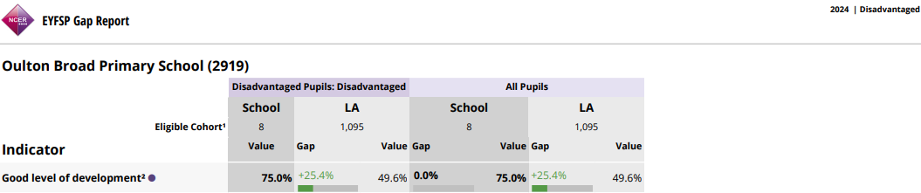
Three quarters of children in Reception at our school achieved a GLD this year. The percentage was exactly the same for our PP eligible children. This represents a 25% positive gap between our disadvantaged children and the other disadvantaged children in our county.
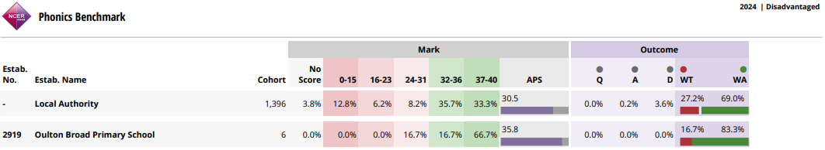
At the end of Y1 when the children sit their phonics check, the average score of our disadvantaged children was over 5 points higher than their counterparts in Suffolk.
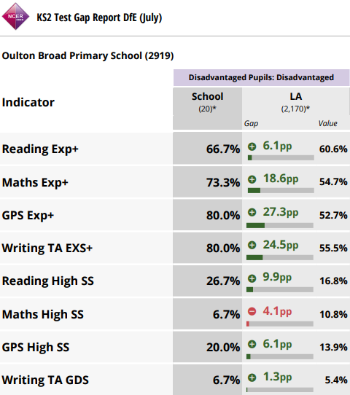
In every KS2 measure, barring reaching GDS in Maths, our disadvantaged children ranged from being 5%-27% ahead of their disadvantaged peers in Suffolk.
88% of children eligible for Free School Meals participated in after school clubs.
It is vital to note that despite these figures demonstrating the fact that our work to improve standards for our disadvantaged children is showing positive impacts, we will not cease striving to find innovative, creative ways to further develop our ability to help these children more effectively.

